What is the output of the following code?

int doSomething(int a, int b) { if (b==1)
return a; else
return a + doSomething(a,b-1); } doSomething(2,3);
a) 4 b)2 c)3 d)6
Correct Answer d) 6

Explanation: In the first function call, 2 + doSomething(2,2) In the second function call, 2 + 2+ doSomething(2,1)
In the third function call, (b==1) is met. So, return 2. The answer is 2+2+2=6

Select the correct output of the following code.

int rec(int num){

return (num) ? num%10 + rec(num/10):0;

}

main(){ printf("%d",rec(55));
}

a)10 b)25 c)5 d)15.

Correct Answer: a)10

Explanation: If we pass the value 55 in the function rec, then int rec(55)?55%10 + rec(55/10):0;
So, 55%10= 5 and 55/1-=5, Hence , 5+5 = 10 (Answer)

What is the output of the following code?

int something(int number) { if(number <= 0) return 1;else
return number * something(number-1);

}

something(4);

a)12 b)24 c)1 d) 0

Correct Answer: b)24 Explanation: For the value 4, return 4 * (something(3)); return 4 * (3 * something(2)))
return 4 * (3 * (2 * something(1))));
return 4 * 3 * 2 *1 = 24. (Answer)

What is the output of the following code for sum(8)?

int sum(int n) {

if (n==0) return n; else
return n + sum(n-1);

}
a)40 b)36 c)8 d) 15

Correct Answer: b)36

Explanation: Given, the value of n is 8. So, it is not equal to 0, so goes to the else part like the following:

8 + sum(7)
8 + 7 + sum(6)
8 + 7 + 6 + sum(5)
8 + 7 + 6 + 5 + sum(4)
8 + 7 + 6 + 5 + 4 + sum(3)
8 + 7 + 6 + 5 + 4 + 3 + sum(2)
8 + 7 + 6 + 5 + 4 + 3 + 2 + sum(1)
8 + 7 + 6 + 5 + 4 + 3 + 2 +1 = 36. (Answer)

What is the output of the following code?

main(){

int i, n; n = f(6); printf("%d", n);

}

f(int x){

if(x == 2) return 2; else printf("+");
f(x-1); } }

a)++++2 b)++++++2 c)+++++ d) 2

Correct Answer: a)++++2

Explanation: When x = 6; ‘+’ is printed; When x = 5; ‘+’ is printed; When x = 4; ‘+’ is printed; When x = 3; ‘+’ is printed; When x = 2; ‘2’ is printed. So, the output is ++++2.

How many times ‘a’ will be printed for the following code?

main(){

int a; a= f1(10); printf(“%d”, a);

}

f1(int b){

if(b == 0)

return 0; else{ printf(“a”);
f1(b--); } }
a) 9 b)10 c)0 d) Infinite number of times

Correct Answer: d) Infinite number of times

Explanation: Though there is an exit condition, but there will be an infinite loop. Because there is a decrement operator (b--) used to call the recursive function. That’s why the answer is option d.

What will be the output of the following code?

main(){

int n = 10; int f (int n);

printf(“%d”, f(n)); } int f(int n) {
if (n > 0)

return (n+f(n-2)); }
a) 10 b)80 c)30 d) error

Correct Answer: c) 30

Explanation: The recursive function returns n+f(n-2) till 10 >0. So, the above code will be evaluated as 10+8+6+4+2=30.

What will be the output of the following code?

main(){

printf(“Recursion checking”);

main();

return 0; }
a) ‘Recursion checking’ is printed once b)0 is returned
c) ‘Recursion checking’ infinite number of time d) Output screen will be empty

Correct Answer: c) ‘Recursion checking’ infinite number of time

Explanation: main function is called inside the main function, which is recursion. There is no exit condition given, so the code will run infinitely. To prevent this, an exit condition should be set inside the function.

What will be the output of the following C code if the input given to the
code shown below is “sanfoundry”?

main(){ void f(void);
printf("enter the word\n"); f(); }
void f(void) { char c;
if((c=getchar())!=NL){ f();
printf("%c",c); } return; }
a) sanfoundry b) infinite loop
c) yrdnuofnas d) fnasyrdnuo

Correct Answer: c) yrdnuofnas

Explanation: The above code prints the reverse of the word entered. The recursive function terminates when getchar() is equal to null.

Consider the following recursive implementation and state which of the lines should be inserted to complete the given code.

int fibo (int n){

if(n == 1)

return 0;

else if (n ==2) return 1;
return ;

}

main(){

int n =5;

int ans = fibo(n); printf(“%d”, ans); return 0; }
a) fibo (n – 1) b) fibo(n -1) + fibo (n-2)
c) fibo(n) + fibo (n-1) d) fibo(n-2) + fibo (n-1)

Correct Answer: b) fibo(n -1) + fibo (n-2)

Explanation: The line fibo(n -1) + fibo (n-2) should be inserted as per the fibonacci series calculation rule.

What is the output of the following code?

int fibo (int n){

if(n == 1)

return 0;

else if (n ==2) return 1;
return fibo(n -1) + fibo (n-2) ; }

main(){

n=-1;

int ans = fibo (n); printf(“%d”, ans); return 0; }
a) 0 b) 1
c) Compile time error d) Run time error

Correct Answer: d) Run time error

Explanation: Since negative numbers are not handled by the program, the function fibo() will be called infinite times and the program will produce a run time error when the stack overflows.

Does the following function correctly represent the recursive approach to reverse a stack?

int reverse (int n){ if(s.size() > 0){
int x = s.top();

s.pop(); reverse();
Bottominsert(x); } }

a) Yes b) No

Correct Answer: a) Yes

Explanation: We keep on holding the elements in call stack until we reach the bottom of the stack. Then we insert elements at the bottom. This reverses our stack.

What will be the output if we put print(12)?

void print(int n){ if (n == 0) return;
printf("%d", n%2); print(n/2); }
a) 0011 b) 1100
c)0101 d)1001

Correct Answer: a) 0011

Explanation: We put print(12), so n==0 is not matched, hence the control goes to printf function. Now, 12%2 = 0, So 0 is printed. n becomes n/2=> 12/2=6.
6%2 = 0, So 0 is printed. n becomes n/2=> 6/2 =3.
3%2 = 1, So 1 is printed. n becomes n/2=> 3/2 =1.
1%2 = 1, So 1 is printed. n becomes n/2=> 1/2 =0.
Now, n becomes 0, n==0 executes and return. So, the output is 0011.

What will happen when the below code snippet is executed?

void my_recursive_function(){ my_recursive_function(); } int main() { my_recursive_function(); return 0; }

- The code will be executed successfully and no output will be generated
- The code will be executed successfully and random output will be generated
- The code will show a compile time error
- The code will run for some time and stop when the stack overflows

Correct Answer: d) The code will run for some time and stop when the stack overflows

Explanation: Every function call is stored in the stack memory. In this case, there is no terminating condition(base case). So, my_recursive_function() will be called continuously till the stack overflows and there is no more space to store the function calls. At this point of time, the program will stop abruptly.

What will be the output of the following code?

void my_recursive_function(int n){ if(n == 0)
return; printf("%d ",n);
my_recursive_function(n-1); } int main() { my_recursive_function(10);
return 0; }
a) 10 b)1 c)10 9 8 ………. 1 0 d)10 9 8 7……1

Correct Answer d)10 9 8 7……1

Explanation: When the value is given 10, n==0 doesn’t match. So, printf will work and
10 will be printed. Then, n becomes 10-1=9.
n==0 not matched, 9 will be printed. Then, n becomes 9-1=8. n==0 not matched, 8 will be printed. Then, n becomes 8-1=7. n==0 not matched, 7 will be printed. Then, n becomes 7-1=6.

n==0 not matched, 6 will be printed. Then, n becomes 6-1=5. n==0 not matched, 5 will be printed. Then, n becomes 5-1=4. n==0 not matched, 4 will be printed. Then, n becomes 4-1=3. n==0 not matched, 3 will be printed. Then, n becomes 3-1=2.
…………………………………………………………………
So, until the n==0 matched, 10 9 8 7 6 5 4 3 2 1 will be printed.

What is the base case for the following code?

void my_recursive_function(int n){ if(n == 0)
return; printf("%d ",n);
my_recursive_function(n-1); } int main(){ my_recursive_function(10);
return 0; }

- return
- printf(“%d “, n)
- if(n == 0)
- my_recursive_function(n-1)

Correct Answer: c) if(n == 0)

Explanation: For the base case, the recursive function is not called. So, “if(n == 0)” is the base
case.

What will be the output of the following code?

void my_recursive_function(int n){ if(n == 0){
printf("False"); return; } if(n == 1){ printf("True"); return; } if(n%2==0)
my_recursive_function(n/2); else{
printf("False"); return; } } int main(){
my_recursive_function(100); return 0; }
a) True b) False
Correct Answer: b) False

Explanation: The function checks if a number is a power of 2. Since 100 is not a power of 2, it prints false.

What will be the output of the following code?

int count = 0;

void my_recursive_function(char *s, int i){ if(s[i] == '\0')

return;

if(s[i] == 'a' || s[i] == 'e' || s[i] == 'i' || s[i] == 'o' || s[i] == 'u') count++;
my_recursive_function(s,i+1); } int main(){
my_recursive_function("thisisrecursion",0); printf("%d", count);
return 0;

}

a) 6 b) 9 c)5 d)10

Correct Answer: a)6

Explanation: The function counts the number of vowels in a string. In this case the number is vowels is 6.

What will be the output of the following code?

void my_recursive_function(int *arr, int val, int idx, int len){ if(idx == len){
printf("-1"); return ;
}

if(arr[idx] == val){ printf("%d",idx); return;
}

my_recursive_function(arr,val,idx+1,len); } int main(){
int array[10] = {7, 6, 4, 3, 2, 1, 9, 5, 0, 8};

int value = 2; int len = 10;
my_recursive_function(array, value, 0, len); return 0;
}
a) 3 b) 4 c)5 d)6

Correct Answer: b)4

Explanation: The program searches for a value in the given array and prints the index at which the value is found. In this case, the program searches for value = 2. Since, the index of 2 is 4(0 based indexing), the program prints 4.

What is the output of the following code?

int get_sum(int n){ int sm, i;
for(i = 1; i <= n; i++) sm += i;
return sm; } int main(){
int n = 10;

int ans = get_sum(n); printf("%d",ans); return 0; }

a) 55 b)45 c)35 d) Depends on compiler

Correct Answer: d) Depends on compiler

Explanation: Since the variable “sm” is not initialized to 0, it will produce a garbage value. Some compiler will automatically initialize variables to 0 if not initialized. In that case the value is 55. Hence the value depends on the compiler.

What is the output of the following code?

int recursive_sum(int n){ if(n == 0)
return 0;

return n + recursive_sum(n - 1); } int main(){
int n = 5;

int ans = recursive_sum(n); printf("%d",ans);
return 0; }
a) 10 b)15 c)21 d) 14

Correct Answer: b) 15

Explanation: The above code prints the sum of first 5 natural numbers, which is 15.

What is the output of the following code?

int recursive_sum(int n){ if(n == 0)
return 0;

return n + recursive_sum(n - 1); } int main(){

int n = -4;

int ans = recursive_sum(n); printf("%d",ans);
return 0; }

a) 0 b)-10 c)10 d) Run time error

Correct Answer: d) Run time error

Explanation: The above code doesn’t handle the case of negative numbers and so the function recursive_sum() will be called again and again till the stack overflows and the program produces a runtime error.

What is the output of the following code?

int numPrint(int); int main(){
int n = 1;

printf("\n\n Recursion : print first 50 natural numbers :\n"); printf(" \n"); printf(" The natural numbers are :");
numPrint(n); printf("\n\n"); return 0;
}

int numPrint(int n){ if(n<=5){
printf(" %d ",n); numPrint(n+1);
} }

a)2,4,5,1,3 b)1,2,3,4,5
c)3,1,2,5,4 d)2,1,3,4,5

Correct Answer: b)1,2,3,4,5

Explanation:
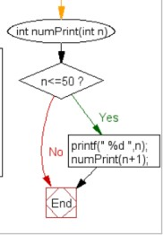
- What is the output of the following code if n1=25?
int DigitSum(int n1){ if(n1 == 0)
return 0;

return ((n1 % 10) + DigitSum(n1 / 10));//calling the function DigitSum itself

}
a)7 b)2
c)1 d)4

Correct Answer: a)7

Explanation:
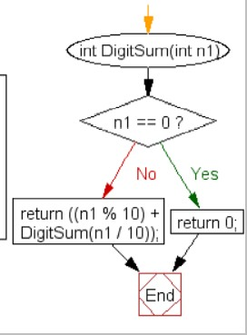

- What is the output of the following code?
void fun(int n){ if(n>0)
fun(n-1);

printf(“%d”, n); } main(){
fun(3);

return 0; }

a)1123 b)0133
c)0123 d) None of the above

Correct Answer: c) 0123

Explanation: Here, if the value of n is greater than 0, then the function fun(n-1) is called. And
if the condition doesn’t meet, then the values in the stack are printed.
So, 3 is passed, 3>0; 3 is in the stack and 3-1=2 is passed. 2 is passed, 2>0; 2 is in the stack and 2-1 =1 is passed.
1 is passed, 1>0; 1 is in the stack and 1-1 =0 is passed.
0 is passed. 0>0 is not right; 0 is in the stack and n-1 doesn’t get activated.
So, in LIFO manner, 0123 is the answer.
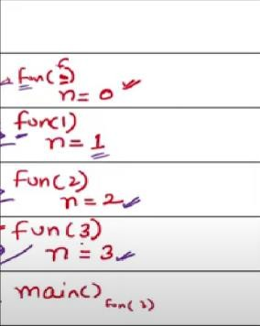

If get(6) function is called in the main, then how many times the get() function will be invoked before returning to the main?

void get(int n){

if(n<1) return; get(n-1);
get(n-3);

printf(“%d”, n); }

a)15 b)25 c)35 d) 45

Correct Answer: b) 25

Explanation: get(6) is passed, so, 6<1 is not correct and get (n-1) is called, hence we get get(5). Like this, get(5), get(4), get(3), get(2), get(1), get(0) is called.
When we have get(0),then 0<1 is satisfied and the function returns to the get(1) function. Then again we have to call the get(n-3). So, 1-3=-2 , we have now get(-2). Again -2<1, so the function returns. Like this, the process continues.
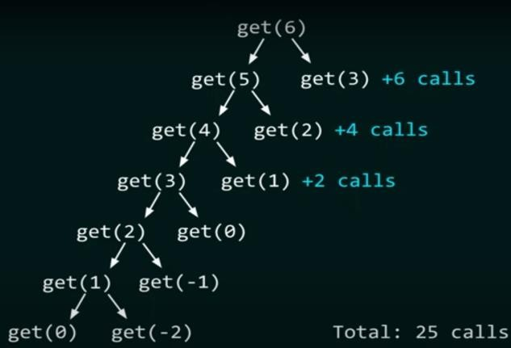
The call hierarchy is illustrated in the picture. Total 25 calls will be the answer.

What will be the output by the function call compute(24,2)?

def compute (x,y) : if x>1:
if x % y == 0:

print(y, end= ‘ ’)

compute(int(x/y),y)

else:

compute(x, y+1)

a)2 2 2 3 b)2 2 2 2
c)2 3 3 3 d) None of the above
Correct Answer: a) 2 2 2 3.

Explanation: Here, given compute(24,2); So, x=24 and y=2.

Now the condition, 24 > 1 (True) and 24 % 2 = 0 (True), So value of y is printed, which is 2.

And then compute function is updated, compute(int(x/y),y) => (24/2,2) => 12,2 ; x=12,y=2.
Now the condition, 12 > 1 (True) and 12 % 2 = 0 (True), So value of y is printed, which is 2. And then compute function is updated, compute(int(x/y),y) => (12/2,2) => 6,2 ; x=6,y=2. Now the condition, 6> 1 (True) and 6 % 2 = 0 (True), So value of y is printed, which is 2.
And then compute function is updated, compute(int(x/y),y) => (6/2,2) => 3,2 ; x=3,y=2.

Now the condition, 3 > 1 (True) and 3 % 2 = 0 (False), So compute(x, y+1) is called. x= 3, y=3.
Now the condition, 3> 1 (True) and 3 % 3 = 0 (True), So value of y is printed, which is 3. And then compute function is updated, compute(int(x/y),y) => (3/3,3) => 1,3 ; x=1,y=3. Now the condition, 1> 1 (False).
So, final output is 2 2 2 3.

- What will the following function check() return when the values of m and n both are equal to 5?

def check (m,n) :

if n == 1:

return -m

else:

return (m+1) + check(m+1, n-1)

a)21 b)12
c)30 d) 16
Correct Answer: a) 21

Explanation: Here, we put the values m=5 and n=5. We check till the value n==1 satisfies.
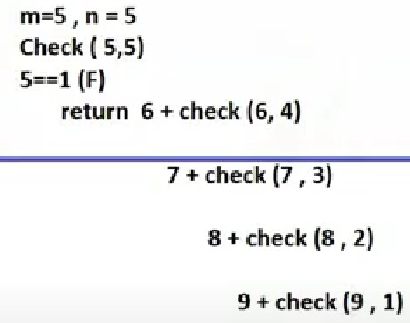

So, when we get the iteration 9 + check(9,1); the condition n==1 met. So, now it returns -m, which is -9.

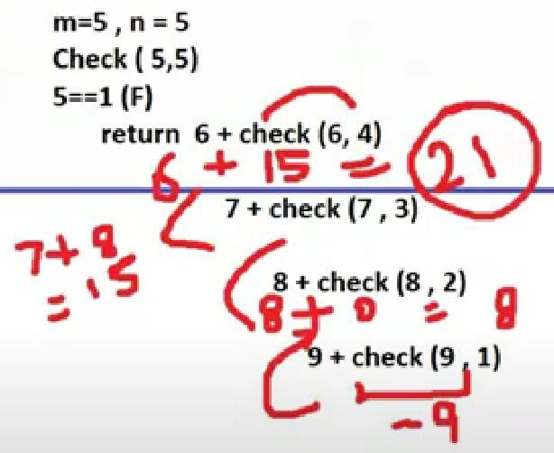

So, 9+ (-9) =0; 8+0=8; 7+8=15; 15+6 =21. So, final result is 21.

What will the function magicfun() return when the value of n is 7?

int magicfun(int n){

if(n ==0)

return 0; else
return magicfun(n/2) * 10 + (n % 2); }
a)100 b)111
c)1110 d) None of the above

Correct Answer: b) 111

Explanation: For n=7, the control of the program goes to else condition. magicfun(n/2) * 10

+ (n % 2) returns==>

magicfun(3) * 10 + 1 from (magicfun (7/2) * 10 + (7%2)
Then, magicfun(1) * 10 + 1 from (magicfun (3/2) * 10 + (3%2)
Then, magicfun(0) * 10 + 1 from (magicfun (1/2) * 10 + (1%2)
magicfun(0) * 10 + 1 => 0 +1 =1 is returned and the result is added to the magicfun(1) * 10 + 1. Hence value is 1 * 10 + 1 = 11 is returned and added to the magicfun(3) * 10 + 1.
Hence the final value is 11*10+1= 111.

- Predict the output:
def fun(i,j):

if(i==0):

return j else:
return fun(i-1,j+1) print(fun(4,8))
a)10 b)11 c)12 d)15

Correct Answer: c) 12

Explanation: Given value, i=4, j=8. So, after first call, i becomes i-1 and j becomes j+1. So, i= 3, j=9.
i=2, j=10; i=1, j=11;
i=0,j=12; When, i==0, j is 12 and returned. Answer: 12.
- Predict the output:
public static void main(String[] args) { System.out.println(equation(8)); }
public static int equation(int a) { if(a <= 5) {
return 12; }

return equation(a-2) * equation(a-1); }

a)104 b)1728 c)144 d)248832

Correct Answer: d)248832

Explanation: The function equation is a recursive method, meaning that it calls itself. The easiest way to trace a recursive method is to first pay heed to its stopping case. For this, it is:
if(a <= 5) { return 12;}
In this case, it returns 12 for any values less that or equal to 5. Now: equation(8) = equation(6) * equation(7)
equation(7) = equation(5) * equation(6) equation(6) = equation(4) * equation(5)
Therefore, equation(6) is: 12 * 12 or 144.Thus, we know: equation(7) = 12 * 144 = 1728. And, equation(8) = 144 * 1728 = 248832

What will be the output for the function call foo(5,9)?:

public static int foo(int a, int b) { if(b <= 1 || b <= a) { return 1; }
return (b - a) * foo(a,b-1); }

a)36 b)18 c)32 d)24

Correct Answer: d)24

Explanation: The function foo is recursive, meaning that it calls itself. Therefore, you should start by looking for its termination point. Based on the definition above, it terminates when either b <= 1 or b <= a. In these two cases, it will return 1.
Now, let us do our trace of the calls: foo(5,9) = (9-5) * foo(5,8) = 4 * foo(5,8)
foo(5,8) = (8-5) * foo(5,7) = 3 * foo(5,7)
foo(5,7) = (7-5) * foo(5,6) = 2 * foo(5,6)
foo(5,6) = (6-5) * foo(5,5) = 1 * foo(5,5) foo(5,5) = 1

Therefore, carefully tracing back up, we get:

foo(5,9) = 4 * 3 * 2 * 1 * 1 = 24.

- What will be the output for the function call foo(8)?:
public static int foo(int a) { if(a <= 3) {
return 1; }

return a * foo(a - 3) * foo(a - 4); }

a)240 b)160 c)140 d)144

Correct Answer: b)160

ExplanationThe foo method is recursive, so you will need to find the stopping case first. This happens when a <= 3. At that time, the method returns 1. Now, based on this fact, we can begin to trace the method:
foo(8) = 8 * foo(5) * foo(4) foo(5) = 5 * foo(3) * foo(1) foo(4) = 4 * foo(1) * foo(0) foo(0) = foo(1) = foo(3) = 1; Thus, we know: foo(8) = 8 * 5 * 1 * 1 * 4 * 1 * 1 = 160. 34. What will be the output ?:

public void draw() {

recurs(11); }

void recurs(int count){ if (count == 0)
return; else {
System.out.print(count + " "); int recount = count - 2; recurs(recount);

return; } }

a)11 9 7 5 3 1 b)9 7 5 3 1 c)11 9 7 5 3 1 -1 d)Infinite Loop

Correct Answer: d) Infinite Loop

Explanation: This creates an infinite loop because the condition to end the loop is never reached. Since count is never equal to 0, count continues to be entered into recurs over and over with no end.

What will be the output?

public void draw() { recurs(10); }
void recurs(int count){ if (count == 0)
return; else {
System.out.print(count + " "); int recount = count - 2; recurs(recount);
return; } }

a)8 6 4 2 b)10 8 6 4 2 c)10 8 6 4 2 0 d)8 6 4 2 0

Correct Answer: b) 10 8 6 4 2

Explanation: The number 10 is inputed into recurs and prints count, subtracts two from count, then re-entered into recurs. Thus, the first iteration gives, 10. The second iteration gives as, 10, 8.It is written this way because it places 8 after the value from the first iteration. Continuing in

this fashion we get,10 8 6 4 2. When count reaches 0, nothing is printed.

What will be the output of the following code?

void myrecfun(int n){ if(n == 0) {
printf("False"); return; }
if(n == 1) { printf("True"); return; } if(n%2==0) myrecfun(n/2); else { printf("False"); return; } }
int main() { myrecfun(100); return 0; }
  - True b) False
Correct Answer: b) False

Explanation: The function checks if a number is a power of 2. Since 100 is not a power of 2, it prints false.

What will be the output of the following code if the input range is 1 to 15?

void EvenAndOdd(int stVal, int n); int main(){
int n;

printf("\n\n Recursion : Print even or odd numbers in a given range :\n"); printf(" \n");

printf(" Input the range to print starting from 1 : "); scanf("%d", &n);

printf("\n All even numbers from 1 to %d are : ", n);

EvenAndOdd(2, n);//call the function EvenAndOdd for even numbers

printf("\n\n All odd numbers from 1 to %d are : ", n); EvenAndOdd(1, n);// call the function EvenAndOdd for odd numbers printf("\n\n");
return 0; }

void EvenAndOdd(int stVal, int n){ if(stVal > n)
return;

printf("%d ", stVal);

EvenAndOdd(stVal+2, n);//calling the function EvenAndOdd itself recursively

}
  - Print all even numbers from 1 to 15
  - Print all odd numbers from 1 to 15
  - Both (a) and (b)

  - None of the above

Correct Answer: c) Both (a) and (b)

Explanation:
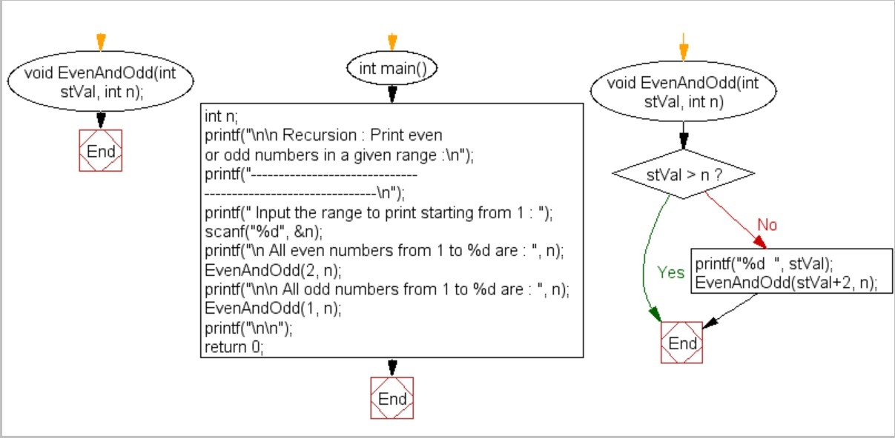

- What will be the output of the following code for the given value of bnum=4 and pwr=3?
long int CalcuOfPower(int x,int y){ long int result=1;
if(y == 0) return result;

result=x*(CalcuOfPower(x,y-1)); //calling the function CalcuOfPower itself recursively
}

int main(){

int bNum,pwr;

long int result;

printf("\n\n Recursion : Calculate the power of any number :\n"); printf(" \n");

printf(" Input the base value : "); scanf("%d",&bNum);

printf(" Input the value of power : "); scanf("%d",&pwr);

result=CalcuOfPower(bNum,pwr);//called the function CalcuOfPower

printf(" The value of %d to the power of %d is : %ld\n\n",bNum,pwr,result);

return 0;

}

a)43 b)64 c)12 d)None of these

Correct Answer: b) 64

Explanation: The code returns the power of a given number and procedure is followed:

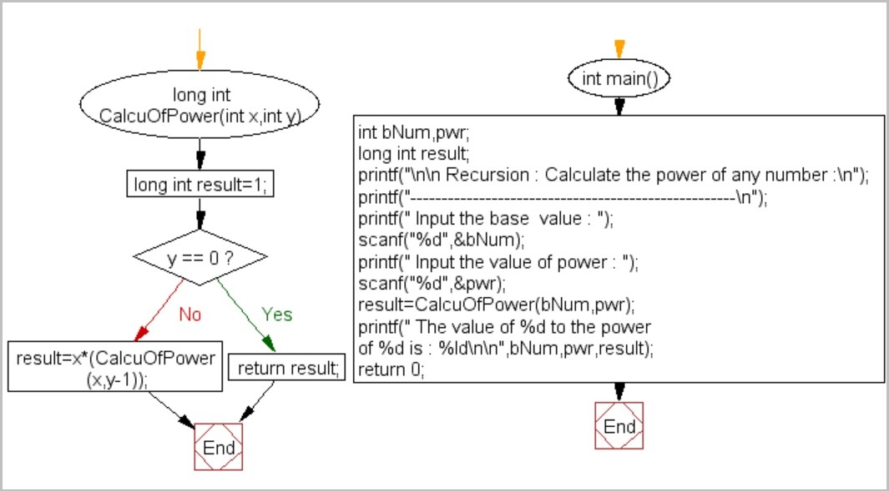

Predict the output:

def my_function(p,q):

if(p==0):

return q else:
return my_function(p-1,q+5) print(my_function(6,10)) a)10 b)11 c)12 d)35
Correct Answer: d) 35
Explanation: Given value, p=6, q=10. So, after first call, p becomes p-1 and q becomes q+5. So, p= 5, q=15; p=4, q=20; p=3, q=25; p=2, q=30; p=1, q=15; p=0, q=35.
When, p==0, q is 35 and returned. Answer: 35.

- What will the function my-function() return when the value of n is 10?
int my-function(int n){ if(n ==0)

return 0; else
return my-function(n/2) * 10 + (n % 2); }

a)1010 b)1111
c)1110 d) None of the above

Correct Answer: a) 1010

Explanation: For n=10, the control of the program goes to else condition. my-function(n/2) * 10 + (n % 2) returns==>
my-function(5) * 10 + 0 from (my-function (10/2) * 10 + (10%2)
Then, my-function (2) * 10 + 1 from (my-function (5/2) * 10 + (5%2)
Then, my-function (1) * 10 + 0 from (my-function (2/2) * 10 + (2%2)
Then, my-function (0) * 10 + 1 => 0 +1 =1 is returned and the result is added to the my-function (1) * 10 + 0. Hence value is 1 * 10 + 0 = 10 and is returned and added to the my-function (2) * 10 + 1. Hence the value is 10*10+1= 101. So, 101 is returned to the my-function(5) * 10 +0 . Hence the final value is 101*10+0= 1010.

What will be the output of the following pseudocode when a=8 and b=9?

Function(input a, input b) If(a < b)
Return Function( b,a) Else If(b!=0)
Return a + Function( a, b-1) Else Return 0;
a)56 b)88 c)72 d) 65

Correct Answer: c) 72
Explanation: Firstly, 8<9 is true, So the function returns (b,a). Hence, (9,8). Then, the condition a<b is not satisfied as a=9 and b=8; so the control goes to else if part.

Now, at call 1, Return a + Function( a, b-1) Hence, 9 + Function (9,7) Then, at call 2, the value which returns is: 9 + Function (9,6.)
Then, at call 3, the value which returns is: 9 + Function (9,5.) Then, at call 4, the value which returns is: 9 + Function (9,4.) Then, at call 5, the value which returns is: 9 + Function (9,3.) Then, at call 6, the value which returns is: 9 + Function (9,2.) Then, at call 7, the value which returns is: 9 + Function (9,1.) Then, at call 8, the value which returns is: 9 + Function (9,0.)
At call 9, b!=0 fails and the control goes to the else part. 0 is returned to the previous function.
So, the output value is: 9*8+0=72.

- What will be the output of the following function?
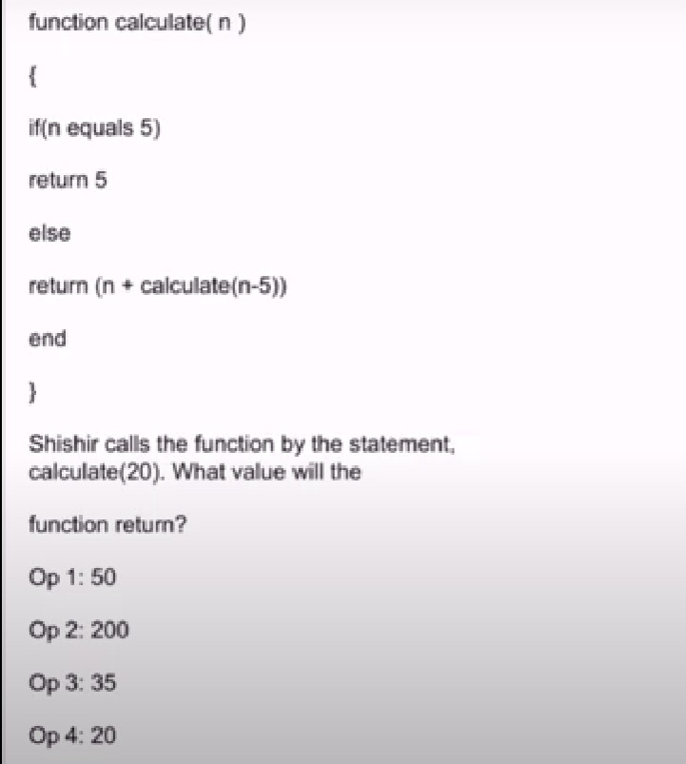
a) Op 1:50 b)Op 2:200 c)Op 3: 35 d) Op 4: 20

Correct Answer: a) Op 1: 50.

Explanation: Given, n=20, so the if condition is failed and the control goes to the else part. At first call, the value returned is: 20 + calculate (15);
At second call, 15 + calculate (10); At third call, 10 + calculate (5);
When n is 5, it meets the if condition and value 5 is returned to the previous function.

So, we get the value 5+10+15+20 = 50.

- What will be the output of the following pseudocode for n=2?
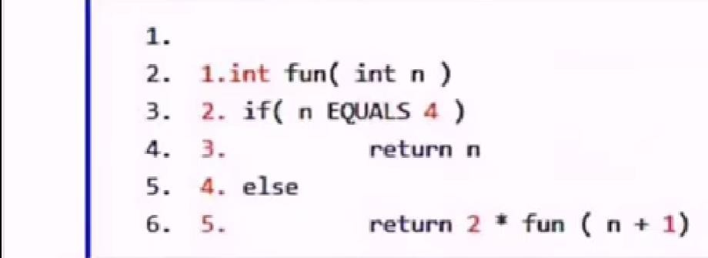

a)2 b)16 c)8 d) 4

Correct Answer: b) 16.

Explanation: Given, n=2, so the if condition is failed and the control goes to the else part.
At first call, the value returned is: 2 * fun(3). At second call, 2 * fun(4).; At third call, if condition is satisfied and the value 4 is returned to the previous function.
So, we get the value 4 * 2 * 2 = 16.

- Fill up the blank in the following code where ?? is denoted.

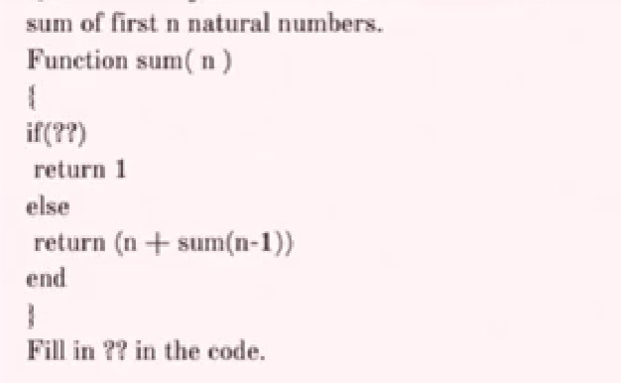

  - n equals 1 b) n equals 2 c) n > = 1 d) n > 1

Correct Answer: a) n equals 1

Explanation: Sum of first n natural number is to be calculated. Natural numbers are 1,2,3,4,5,6,7… up to n. As in the if condition, 1 is returned. So, we can say that only one sum has been done. So, the right answer is n equals one.

What will be the output of the following pseudocode when a=2 and b=4?

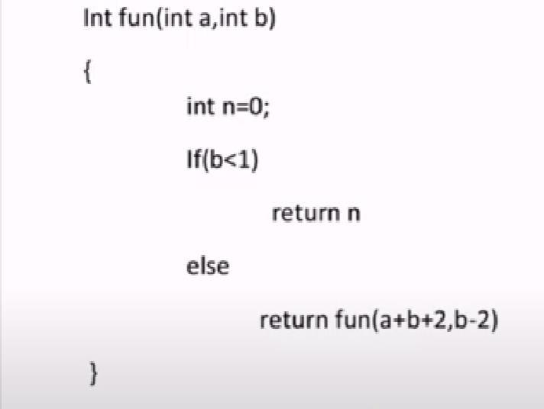

a) 0 b) 22 c) 58 d) 9

Correct Answer: a) 0.

Explanation: b < 1 is not satisfied as b=4. So, the control goes to else part. At first call, return

fun (a+b+2, b-2) returns (8,2).
At second call, the value returned is (12,0). At third call b < 1 is satisfied and n is returned to the previous function. The value of n is 0, given in the question. So, answer is 0+0=0.

What will be the output of the following pseudocode when x=24 and y=2?

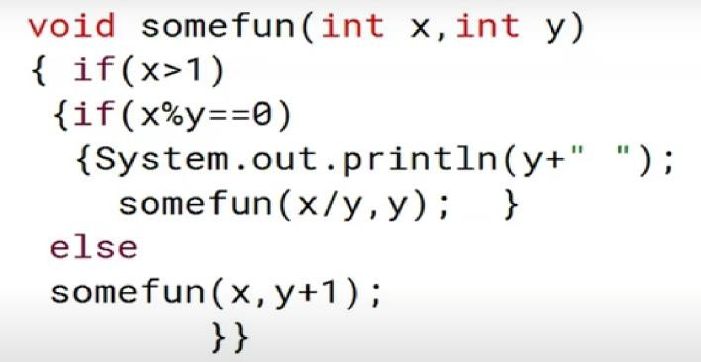

a) 2 2 2 3 b) 2 2 2 2 c) 2 3 2 3 d) 2 3 3 3

Correct Answer: a) 2 2 2 3.

Explanation: x>1 and x %y ==0 both are satisfied, so the value of y is printed as 2. And then, x becomes x/y => 24/2=12 and the new value pair is (12,2).
Again, for the value (x,y) =(12,2) : x>1 and x %y ==0 both are satisfied, so the value of y is printed as 2. And then, x becomes x/y => 12/2=6 and the new value pair is (6,2).
Again, for the value (x,y) =(6,2) : x>1 and x %y ==0 both are satisfied, so the value of y is printed as 2. And then, x becomes x/y => 6/2=3 and the new value pair is (3,2).
Again, for the value (x,y) =(3,2) : x %y ==0 is not satisfied, so the value of y is printed as y+1)=3 .
So, the output is 2 2 2 3.

Consider the following function :

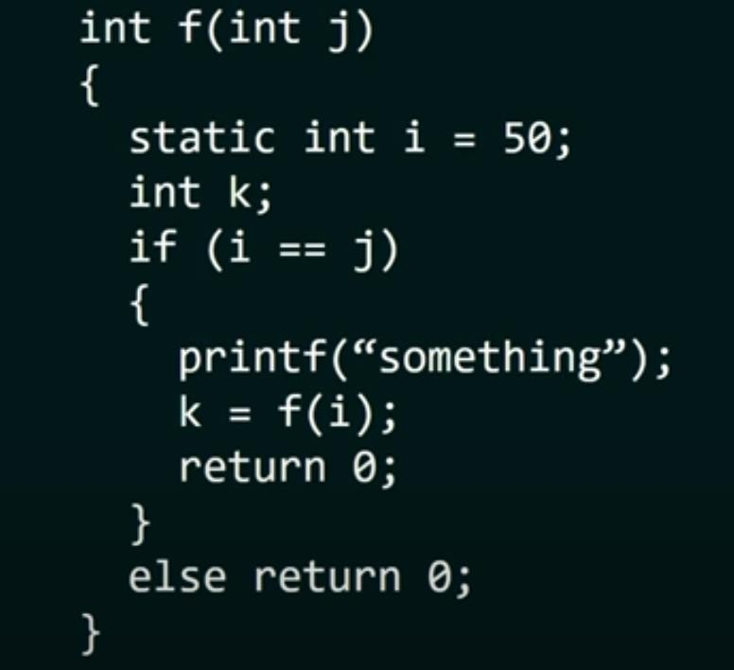

  - The function returns 0 for all the values of j
  - The function prints the string “something” for all the values of j
  - The function returns 0 when j = 50
  - The function will run into an infinite loop when j=50.

Correct Answer: d) The function will run into an infinite loop when j=50.

Explanation: J can have values like 51,52 etc but “something” will be printed only when j is 50, so option b is ruled out. When j is 50, “something” will be printed, so option c is ruled out.
When the value of j is 50, it goes into an infinite loop, hence the option a is also ruled out. Correct answer is (d).

How many times is the function recursive_sum called when the code is

executed?

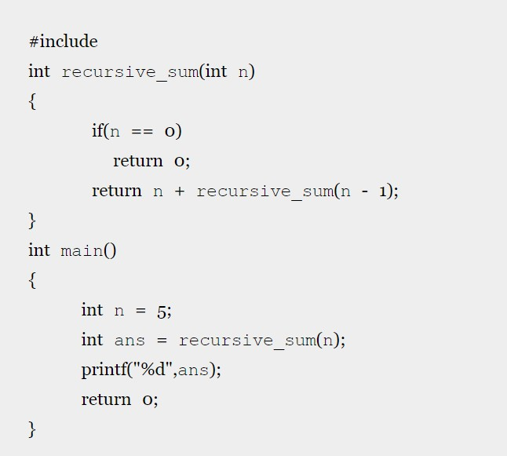

a) 4 b)5 c)6 d)7

Correct Answer: c)6.

Explanation: At the 6th call, n becomes 0 and returns 0. So, 6 time called.

What will be the output of the following code snippet?
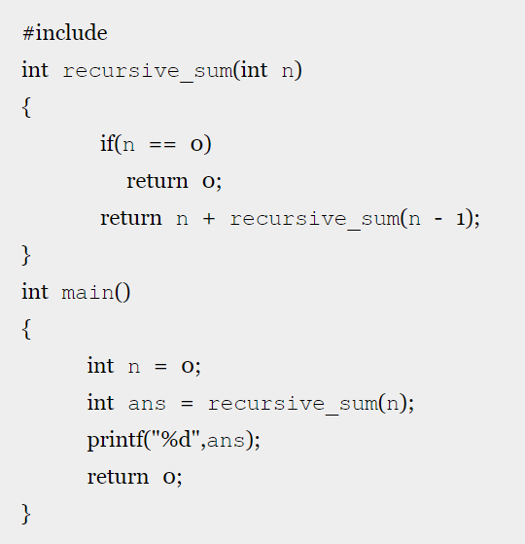

  - -1 b)0 c)1 d)Runtime Error

Correct Answer: b) 0.

Explanation: The program returns the sum of n natural numbers and the value of n is 0. So, the answer is 0.

50. How many times is the recursive function is called when the code is executed?
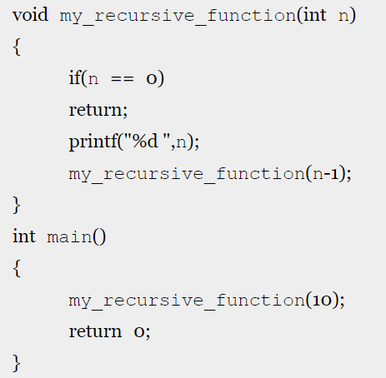

a) 9 b)10 c)11 d) 12

Correct Answer: c) 11.

Explanation: n == 0 is not satisfied and at first call, my_recursive_function(9) is returned. Like the value of n decreases by 1, we get the terminating base case condition at the 11th call.

51.
#include <stdio.h>
int counter = 0;
Int calc (int a, int b) {
int c;
counter++;
if (b==3)
return (a*a*a);
else {
c = calc(a, b/3);
return (c*c*c);
}}
int main (){
calc(4, 81);
printf ("%d", counter);
}

Ans: 4

Explanation:

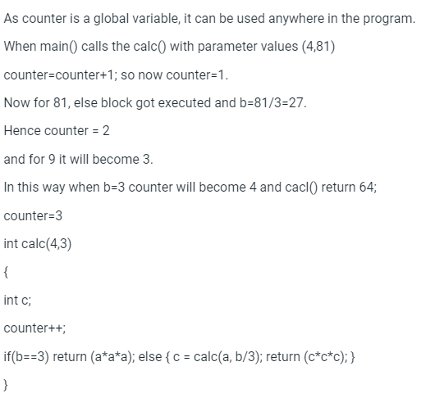

52.Count(x,y) {
if (y != 1){
if (x != 1) {
print("*");
Count(x/2, y);
}
else {
y = y-1;
Count(1024, y);
}
}
}
The number of times that the print statement is executed by the call Count(1024,1024) is _____.

Ans :10230

Explanation:

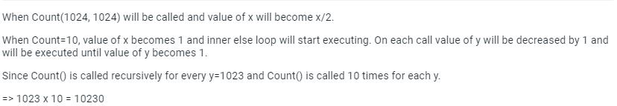
53. Consider the following two functions.
void fun1 (int n) {  if (n == 0) return;  printf ("%d", n);  fun2 (n - 2);  printf ("%d", n);  }  The output printed when fun1 (5) is called is |  | void fun2 (int n) {  if (n == 0) return;  printf ("%d", n);  fun1 (++n);  printf ("%d", n);  }

Ans :53423122233445

Explanation:

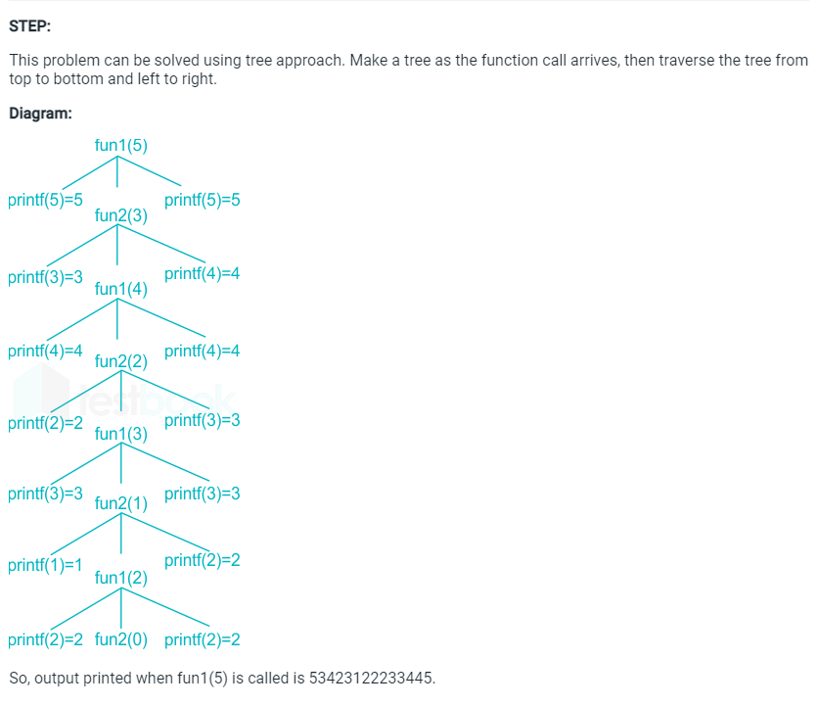

54.int f(int *p, int n)
{ if (n <= 1) return 0;
else return max(f(p+1,n-1),p[0]-p[1]);
}
int main(){
int a[] = {3,5,2,6,4};
printf("%d", f(a,5));}

Answer : 3

Explamation: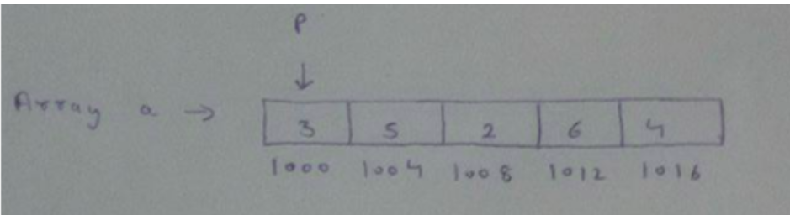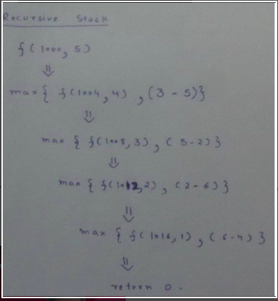

55.
void foo(char *a)
{
if(*a && *a != ‘ ‘)
{
foo(a+1);
putchar(*a);
}
}
The output of the above function on input “ABCD EFGH” is

Answer : DCBA

Explanation:

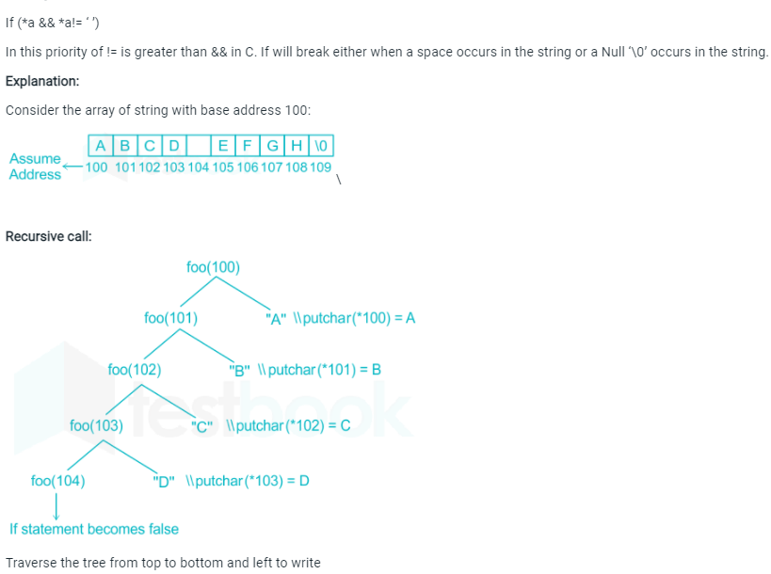

int fun(int n)
{
int x = 1, k;
if (n = = 1) return x;
for (k =1; k<n; ++k)
x = x + fun(k) * fun(n–k);
return x;
}
The return value of fun(5) is _____.

Answer : 51

Explanation:

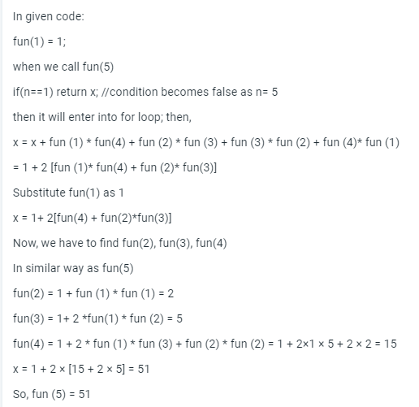

57.
voidget (int n)
{
if (n<1) return;
get (n–1);
get (n–3);
printf(“%d”, n);
}
If get(6) function is being called in main() then how many times will the get() function be invoked before returning to the main()?

Answer : 25

Explanation:

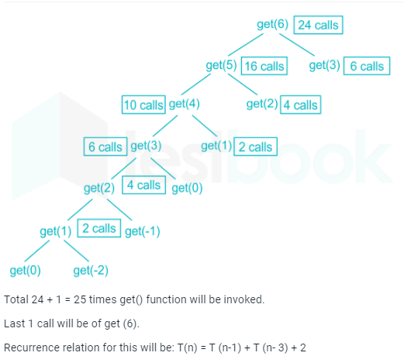
58. What is the return value of f(p,p), if the value of p is initialized to 5 before the call?
int f (int&x, int c) {
c = c - 1;
if (c==0) return 1;
x = x + 1;
return f(x,c) * x;
}

Ans: 6561
Explanation:
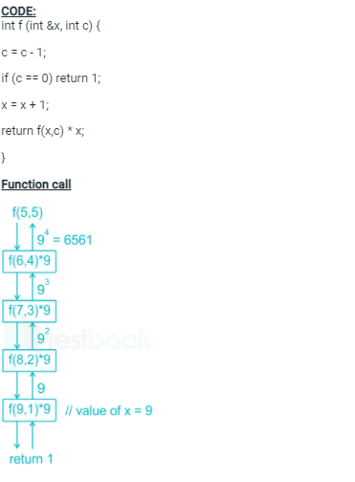
59. Consider the following C function:
Intf(int n)
{static int r = 0;
if (n <= 0) return 1;
if (n > 3)
{r = n;
return f(n-2)+2;
}
return f(n-1)+r;
}
What is the value of f(5)?

Answer : 18
Explanation:
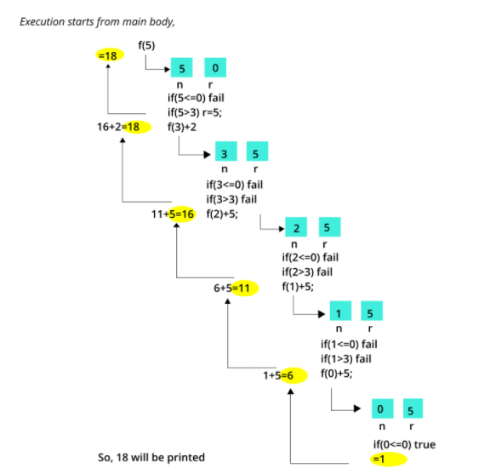
60.What value is returned by the method call sum(3)?

publicint sum(int n)

{

If(n==1)

Return 1;

Else

Return n+sum(n-1);

Ans: 6
Explanation:
The recursive call sum (n - 1) would eventually reach the base case where n is 0 and would return 0 to the previous call.
For example, if the function call sum (3) is issued in main ().
First call to sum: n = 3
Since it is not the base case, we call sum (n - 1), i.e. sum (2).
Second call to sum: n = 2
Since it is not the base case, we call sum (n - 1), i.e. sum (1).
Third call to sum: n = 1
Since it is not the base case, we call sum (n - 1), i.e. sum (0).
Fourth call to sum: n = 0
This executes the base case which returns 0 to the third call.
Third call to sum: n = 1 (as above)
0 is returned as the value of sum (0). We return n + sum (n - 1), which is 1, to the second call.
Second call to sum: n = 2 (as above)
1 is returned as the value of sum (1). We return n + sum (n - 1), which is 3, to the first call.
First call to sum: n = 3 (as above)
3 is returned as the value of sum (2). We return n + sum (n - 1), which is 6, to main ().
61.
Public int result(int n)
{
If(n==1)
Return 2;
Else
Return 2*result(n-1);
}

What value is returned by the method call result(5)?

Ans: 32

Explanation:

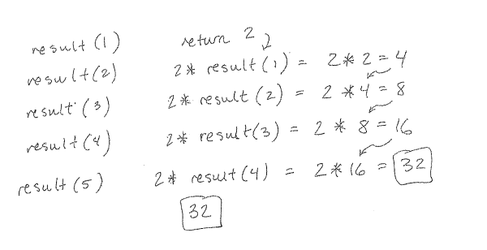

62.

Public int mystery (intn,int a ,int d)

{

If(n==1)

Return a;

Else

Return d+mystery (n-1,a,d);

}

What value is returned by the method mystery(3,2,6) ?

Ans: 14

Explanation:

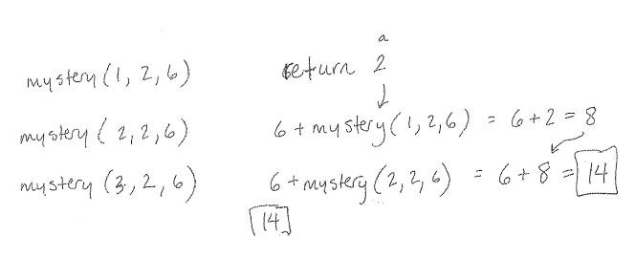

63. publicint f(int k, int n)

{

If(n==k)

Return k;

Else

If(n>k)

Return f(k,n-k);

Else

Return f(k-n,n);
}

What value is returned by the method call f(6,8)?

Ans: 2

Explanation:

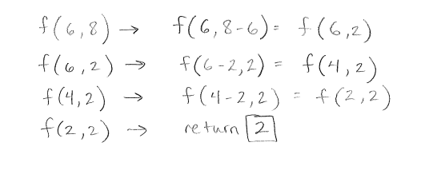

64. intmagicfun(int n)
{
If(n==0)
Return 0;
Else
{
Return magicfun(n/2)*10+(n%2);
Magicfun(7)?
Ans :111
Explanation:
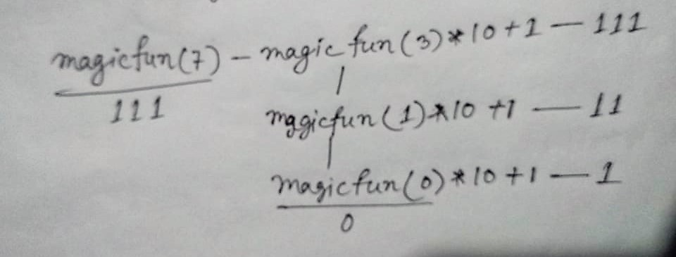

65. def fun(n)
If n>100
Return n-10
Else
Return fun(fun(n+11))
}
Fun(99)?
Ans :91
Explanation:
fun(99) = fun(fun(110)) since 99 ? 100
= fun(100) since 110 > 100
= fun(fun(111)) since 100 ? 100
= fun(101) since 111 > 100
= 91 since 101 > 100
The returned value of fun() is 91 for all integer arguments n 101. This function is known as McCarthy 91 function.

66.
#include <stdio.h>

int fun(int n)
{
if (n == 4)
return n;
else return 2*fun(n+1);
}

int main()
{
printf("%d ", fun(2));
return 0;
}

Ans: 16
Explanation:
Fun(2) = 2 * Fun(3) and Fun(3) = 2 * Fun(4) ....(i)
Fun(4) = 4 ......(ii)
From equation (i) and (ii),
Fun(2) = 2 * 2 * Fun(4)
Fun(2) = 2 * 2 * 4
Fun(2) = 16.

67.Consider the following recursive function fun(x, y). What is the value of fun(4, 3)
int fun(int x, int y)
{
if (x == 0)
return y;
return fun(x - 1, x + y);
}

Ans : 13
Explanation: The function fun() calculates and returns ((1 + 2 … + x-1 + x) +y) which is x(x+1)/2 + y.

68.What does the following function print for n = 25?

void fun(int n)
{
if (n == 0)
return;

printf("%d", n%2);
fun(n/2);
}

Ans: 10011

Explanation: The function mainly prints binary representation in reverse order.

69.What does the following function do?

int fun(int x, int y)
{
if (y == 0) return 0;
return (x + fun(x, y-1));
}

Ans:x*y

Explanation: The function adds x to itself y times which is x*y.

70.What does fun2() do in general?
int fun(int x, int y)
{
if (y == 0) return 0;
return (x + fun(x, y-1));
}

int fun2(int a, int b)
{
if (b == 0) return 1;
return fun(a, fun2(a, b-1));
}

Ans :x^y

Explanation: The function multiplies x to itself y times which is x^y.

71.
#include<stdio.h>
void print(int n)
{
if (n > 4000)
return;
printf("%d ", n);
print(2*n);
printf("%d ", n);
}

int main()
{
print(1000);
getchar();
return 0;
}

Ans: 1000 2000 4000 4000 2000 1000

Explanation:
First time n=1000
Then 1000 is printed by first printf function then call print(2*1000) then again print 2000 by printf function then call print(2*2000) and it prints 4000 next time print(4000*2) is called.
Here 8000 is greater than 4000 condition becomes true and it return at function(2*4000). Here n=4000 then 4000 will again print through second printf.
Similarly print(2*2000) after that n=2000 then 2000 will print and come back at print(2*1000) here n=1000, so print 1000 through second printf.

72.
int fun(unsigned int n)
{
if (n == 0 || n == 1)
return n;

if (n%3 != 0)
return 0;

return fun(n/3);
}

Ans: It returns 1 when n is a power of 3, otherwise returns 0.

Explanation:
Lets solve with example, n = 27 which power of 3.
First time if condition is false as n is neither equal to 0 nor equal to 1 then 27%3 = 0.
Here, again if condition false because it is equal to 0.
Then fun(27/3) will call.
Second time if condition is false as n is neither equal to 0 nor equal to 1 then 9%3 = 0.
Here again if condition false because it is equal to 0.
Then fun (9/3) will call and third time if condition is false as n is neither equal to 0 nor equal to 1 then 3%3 = 0.
Here again if condition false because it is equal to 0.
Then fun(3/3) will call here n==1 if condition gets true and it return n i.e. 1.

73.
#include <stdio.h>
int f(int n)
{
if(n <= 1)
return 1;
if(n%2 == 0)
return f(n/2);
return f(n/2) + f(n/2+1);
}

int main()
{
printf("%d", f(11));
return 0;
}

Ans:5

Explanation: On successive recursion F(11) will be decomposed into
F(5) + F(6) -> F(2) + F(3) + F(3)
-> F(1) + 2 * [F(1) + F(2)] -> 1 + 2 * [1 + F(1)]
-> 1 + 2 * (1 + 1) -> 5.

74.
#include <stdio.h>

int fun(int n)
{
if (n == 4)
return n;
else return 2*fun(n+1);
}

int main()
{
printf("%d ", fun(2));
return 0;
}

Ans:16
Explanation :
Fun(2) = 2 * Fun(3) and Fun(3) = 2 * Fun(4) ....(i)
Fun(4) = 4 ......(ii)
From equation (i) and (ii),
Fun(2) = 2 * 2 * Fun(4)
Fun(2) = 2 * 2 * 4
Fun(2) = 16.

75.#include<stdio.h>
void fun(int x)
{
if(x > 0)
{
fun(--x);
printf("%d\t", x);
fun(--x);
}}
int main(){
int a = 4;
fun(a);
getchar();
return 0;
}

Ans : 0 1 2 0 3 0 1
Explanation :
fun(4);
/
fun(3), print(3), fun(2)(prints 0 1)
/
fun(2), print(2), fun(1)(prints 0)
/
fun(1), print(1), fun(0)(does nothing)
/
fun(0), print(0), fun(-1) (does nothing)

76.
#include<stdio.h>
int fun(int a[],int n)
{
int x;
if(n == 1)
return a[0];
else
x = fun(a, n-1);
if(x > a[n-1])
return x;
else
return a[n-1];
}

int main()
{
intarr[] = {12, 10, 30, 50, 100};
printf(" %d ", fun(arr, 5));
getchar();
return 0;
}

Ans: 100

Explanation:fun() returns the maximum value in the input array a[] of size n.

77.
int fun(inti)
{
if ( i%2 ) return (i++);
else return fun(fun( i - 1 ));
}

int main()
{
printf(" %d ", fun(200));
getchar();
return 0;
}

Ans: 199
Explanation:
If n is odd, then return n, else returns (n-1). Eg., for n = 12, you get 11 and for n = 11 you get 11. The statement “return i++;” returns the value of i only as it is a post-increment.

78.
voidabc(char *s)
{
if(s[0] == '\0')
return;

abc(s + 1);
abc(s + 1);
printf("%c", s[0]);
}

int main()
{
abc("xyz");
return 0;
}

Ans: zzyzzyx

Explanation:
num = 2^len-1
s[0] is 1 time printed
s[1] is 2 times printed
s[2] is 4 times printed
s[i] is printed 2^i times
s[strlen(s)-1] is printed 2^(strlen(s)-1) times
total = 1+2+....+2^(strlen(s)-1)
= (2^strlen(s)) – 1
79.
#include<stdio.h>
int fun(int count)
{
printf("%d\n", count);
if(count < 3)
{
fun(fun(fun(++count)));
}
return count;
}

int main()
{
fun(1);
return 0;
}

Ans: 1
2
3
3
3
3
3
Explanation :
The main() function calls fun(1). fun(1) prints “1” and calls fun(fun(fun(2))). fun(2) prints “2” and calls fun(fun(fun(3))). So the function call sequence becomes fun(fun(fun(fun(fun(3))))). fun(3) prints “3” and returns 3 (note that the count is not incremented and no more functions are called as if the condition is not true for count 3). So the function call sequence reduces to fun(fun(fun(fun(3)))). fun(3) again prints “3” and returns 3. So the function call again reduces to fun(fun(fun(3))) which again prints “3” and reduces it to fun(fun(3)). This continues and we get “3” printed 5 times on the screen.

80.#include <stdio.h>
int fun ( int n, int *fp )
{
int t, f;
if ( n <= 2 )
{ *fp = 1; return 1; }
t = fun ( n-1, fp );
f = t + *fp;
*fp = t;
return f;}
int main()
{
int x = 15;
printf("%d\n",fun(5, &x));
return 0;}

Ans: 5
Explanation:
The program calculates n-th Fibonacci Number. The statement t = fun ( n-1, fp ) gives the (n-1)th Fibonacci number and *fp is used to store the (n-2)th Fibonacci Number. The initial value of *fp (which is 15 in the above program) doesn’t matter. The following recursion tree shows all steps from 1 to 10, for the execution of fun(5, &x).
(1) fun(5, fp)
/ \
(2) fun(4, fp) (10) t = 5, f = 8, *fp = 5
/ \
(3) fun(3, fp) (9) t = 3, f = 5, *fp = 3
/ \
(4) fun(2, fp) (8) t = 2, f = 3, *fp = 2
/ \
(5) fun(1, fp) (7) t = 1, f = 2, *fp = 1
/
(6) *fp = 1

81.
Int check (intm ,int n )
{if(n==1)
Return –m--;
Else
Return ++m +check(m,--n);
}

Check (5,5)?

Ans: 21

82.
#include<stdio.h>
int f(int n, int k){
if(n==0) return 0;
else if(n%2) return f(n/2, 2*k)+k;
else return f(n/2, 2*k)-k;}
int main(){
printf("%d",f(20,1));
return 0;}
Ans: 9
Explanation :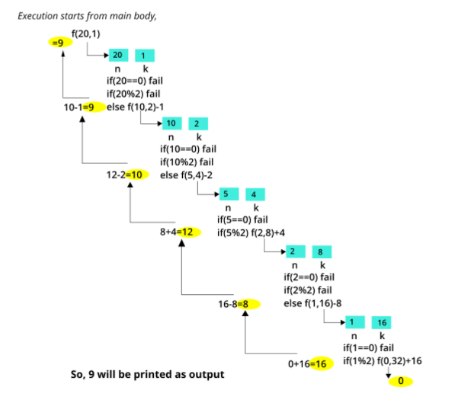

83. What does f(173) print?
void f(int n){
if(n<=1){
printf("%d",n);}
else{
f(n/2);
printf("%d",n%2);
}}
Ans:10101101
Explanation: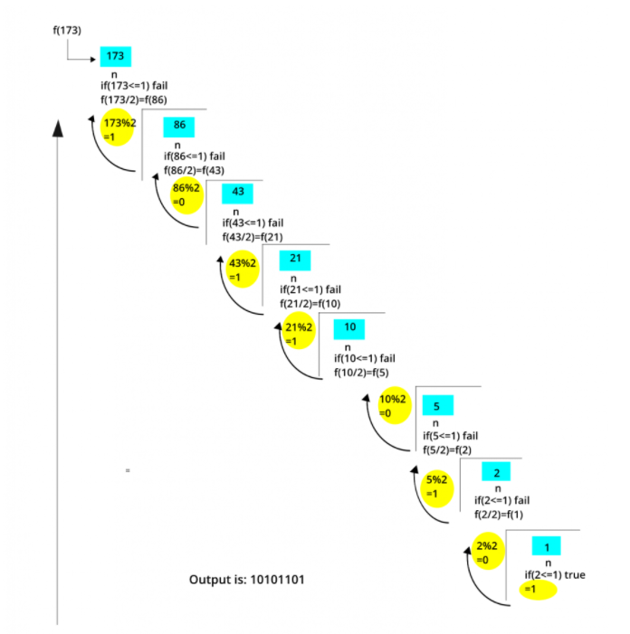

84. What is the return value of the function foo when it is called as foo(345,10)?
unsignedint foo(unsigned int n, unsigned int r)
{
if(n>0) return((n%r)+foo(n/r,r));
else return 0;
}
Ans: 12
Explanation:
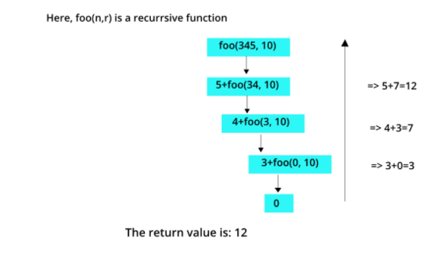

85. fun2(5)?
int fun1(int n)
{
Static inti=0;
If(n>0)
{
i++;
Fun1(n-1);
}
Return(i);
}
Intfun2(int n)
{staticinti=0;
If(n>0)
{
I=i+fun1(n);
Fun2(n-1);
}
Return(i);
}
Ans:55

Explanation:
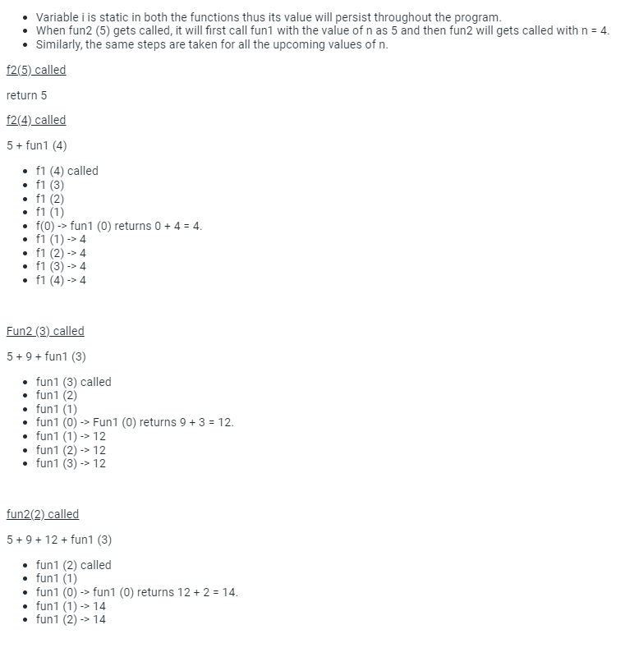
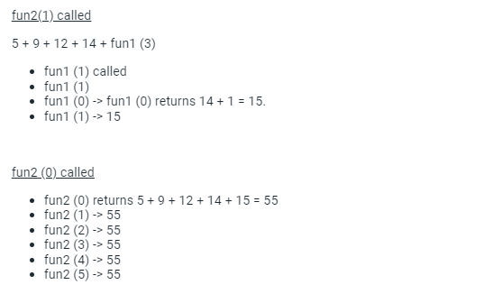

86.
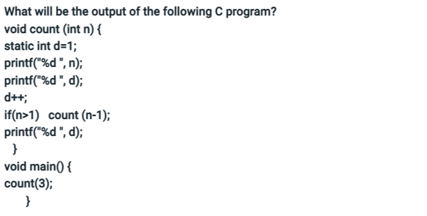
Ans: 312213444
Explanation: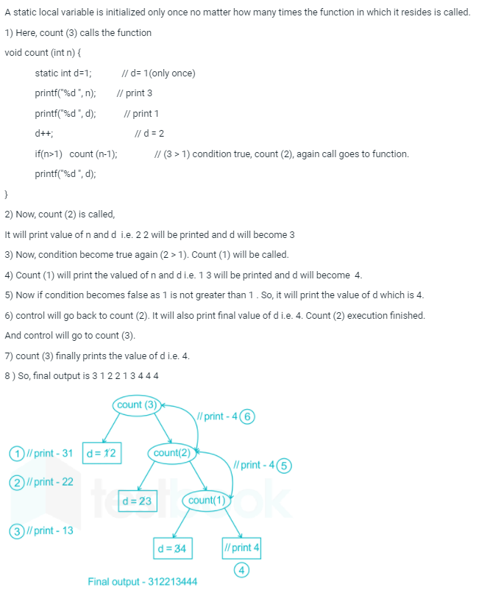

87.What value is returned by the method call mystery(3)?
Public intmystery(int n )
{
If(n<0) return 2;
Else return mystery(n-1) + mystery (n-3);
}

Ans: 14
Explanation:
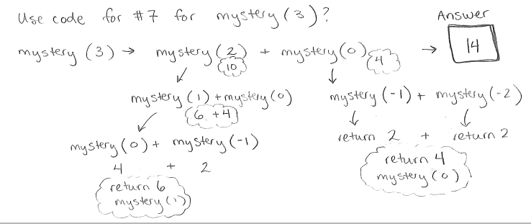

88.
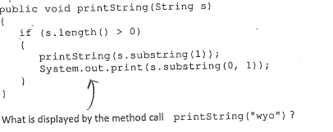

Ans: oyw

Explanation:
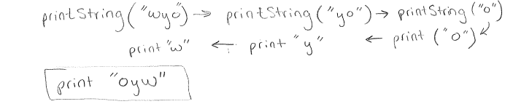

89.
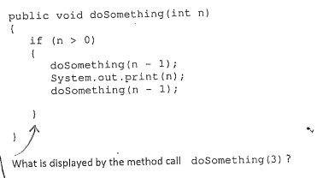
Ans: 1 2 1 3 1 2 1
Explanation;
